**FYP MID DEFENSE Software Design Specifications (SDS)**

**For**

**Classification of X-ray images for Pneumonia and COVID-19 using Deep learning**

**Version 0.2**

Asad Ali (023-20-0115)

Muhammad Hussain (023-20-0076)

Um-e-Hani (023-20-0079)

Supervisor: Dr. Ghulam Murtaza Memon

Date of preparation: November 2023

|  |  |
| --- | --- |
| **Project Code** | **20F-23** |
| **Supervisor** | **Dr. Ghulam Murtaza Memon** |
| **Co-Supervisor** |  |
| **Project Manager** | **Asad Ali** |
| **Project Team** | **Asad Ali**  **Muhammad Hussain**  **Um-e-Hani** |
| **Submission Date** | **29/11/2023** |

**Table of Contents**

1. Introduction to Design Document 5

2. Purpose of Project 5

3. Document Overview 5

4. Design Considerations: 5

1. Document Convention 5

2. Assumptions 6

3. Constraints 6

a) Platform 6

b) Operating System 6

c) Architecture 6

5. Detailed Software Design 6

1. VGG-16 6

2. VGG-19 7

6. ER Diagram 7

7. Use Case Model 8

8. Sequence Diagram 8

9. Interface Design 9

1. Index page 10

2. Sign Up Page 11

3. Login Page 12

4. About Us Page 13

5. Records Page 14

6. Mobile Interface 15

**List of Figures**

Figure 1 . VGG-16 Architecture 6

Figure 2 . VGG-19 Architecture 7

Figure 3 . Entity Relationship Diagram 7

Figure 4 . Use Case Diagram 8

Figure 5 . Sequence Diagram 9

Figure 6 . Home Page of Web Application 10

Figure 7 . Sign Up Page of Web Application 11

Figure 8 . Login Page of Web Application 12

Figure 9 . About Us Page of Web Application 13

Figure 10 . View Records Page of Web Application 14

Figure 11 . Mobile View of Web Application 15

1. **Introduction to Design Document**

This project seeks to design and deploy a deep learning-based, primarily Convolutional Neural Networks (CNNs)-based user-friendly web-based diagnostic tool that classifies chest X-ray pictures into three categories: pneumonia, COVID-19, and normal cases. Using the "COVID-19+PNEUMONIA+NORMAL Chest X-Ray Image Dataset" from Kaggle, the system will be trained and evaluated (Kumar et al., 2022; Shastri et al.). The project involves building a web interface for simple image uploading, developing a rigorous model, and evaluating it using a variety of performance measures. The project addresses the crucial need for prompt diagnosis, particularly in resource-constrained areas, by offering a dependable and user-friendly tool for early respiratory disease detection and differentiation. It also lessens reliance on specialized radiologists and improves the diagnostic abilities of healthcare professionals.

# **Purpose of Project**

The purpose of the "Classification of X-ray images for Pneumonia and COVID-19 using deep learning model" system is to develop an automated system that makes it simple and accurate for users, including physicians, to identify abnormalities in chest X-ray images.

This is accomplished by use of an easily navigable web application. This software design specification document functions as the project's blueprint, defining the high-level design framework as well as the specifications needed for testing and successful completion. Through testing, it will be confirmed that the system satisfies the design requirements and successfully accomplishes the objective of correctly classifying the chest X-ray image.

1. **Document Overview**

The focus of the development project is on providing an intuitive web interface that enables users to enter a chest X-ray image and obtain precise results that identify the abnormality and categorize it as either COVID-19 or pneumonia. Advanced object classification algorithms, computer vision, and other machine learning approaches are used to do this. The goal of the project is to create an internet-connected web application that can be used to access a straightforward and user-friendly graphical user interface. The project's main goal is to help doctors diagnose and treat patients in a quick and accurate manner. The project's goal is to satisfy the requirements of users with and without technical expertise by offering a dependable resource for X-ray interpretation. By decreasing the reliance on manual X-ray interpretation, which can be laborious and error-prone, and increasing the diagnostic process' accessibility and efficiency for both patients and physicians, the aim is to enhance patient care and convenience.

1. **Design Considerations:**

## **Document Convention**

The document uses an Arial font with a font size of 10 and a line spacing of 1.15. For headings the font size of 16 with bold style is used, for subheadings font size of 16 with bold style is used. All of the font is italicized to provide visual interest. These formatting choices are made to ensure that the document is very easy to read and visually appealing as well as maintaining a consistent and professional appearance.

## **Assumptions**

1. It is assumed that end users have a basic understanding of X-ray images.
2. It is assumed that user is proficient in using web based systems.
3. Users have an internet connection to access the application.

## **Constraints**

1. Platform

The application is compatible with any browser with Google Chrome being recommended

1. Operating System

The browser version is compatible with Windows operating system. The system may not be compatible with older versions of operating system or devices with limited hardware capabilities.

1. Architecture
2. **Detailed Software Design**

## **VGG-16**

**Description**

Figure 1 the architecture diagram of VGG-16, which is a deep convolutional neural network architecture widely used for image classification tasks. It consists of 16 layers, including 13 convolutional layers and 3 fully connected layers. VGG-16 is known for its simplicity and uniform structure, utilizing small 3x3 convolutional filters throughout the network.

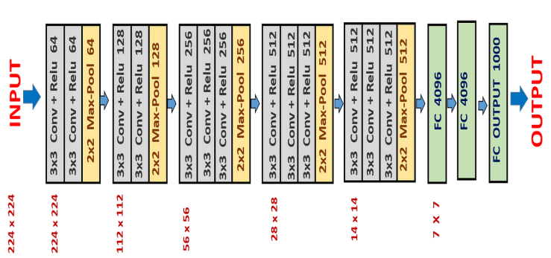

Figure 1. VGG-16 Architecture

## **VGG-19**

**Description**

Figure 2 is the architecture diagram of VGG-19, which is an extension of VGG-16, a deep convolutional neural network architecture widely used for image classification tasks. It consists of 19 layers, including 16 convolutional layers and 3 fully connected layers. VGG-19 is known for its simplicity and uniform structure, utilizing small 3x3 convolutional filters throughout the network.

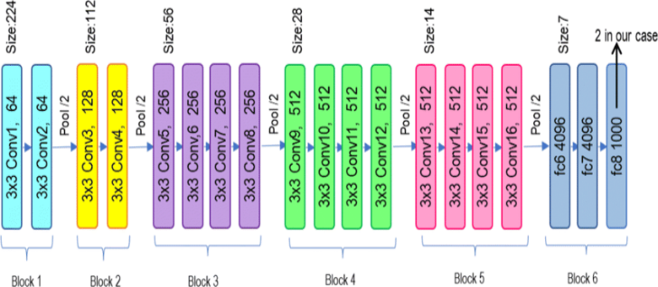

Figure 2. VGG-19 Architecture

1. **ER Diagram**

**Description**

Figure 3 Is the Entity Relationship diagram of proposed system. The user data is stored in User table and the corresponding user records is stored in Records table.

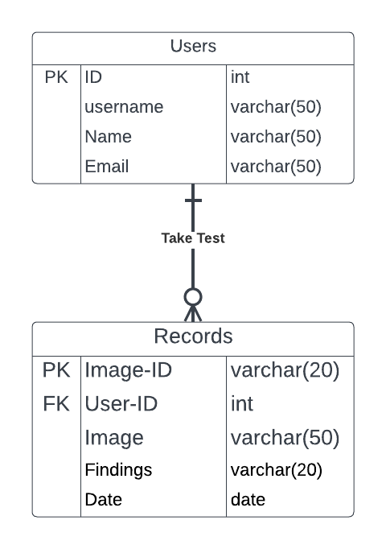

Figure 3. Entity Relationship Diagram

1. **Use Case Model**

**Description**

Figure 4 is the Use Case Diagram shows that users interact with the system by uploading X-ray images, viewing results (requiring login authentication), logging in, signing up, or resetting forgotten passwords. The system authenticates users for result viewing based on login credentials.

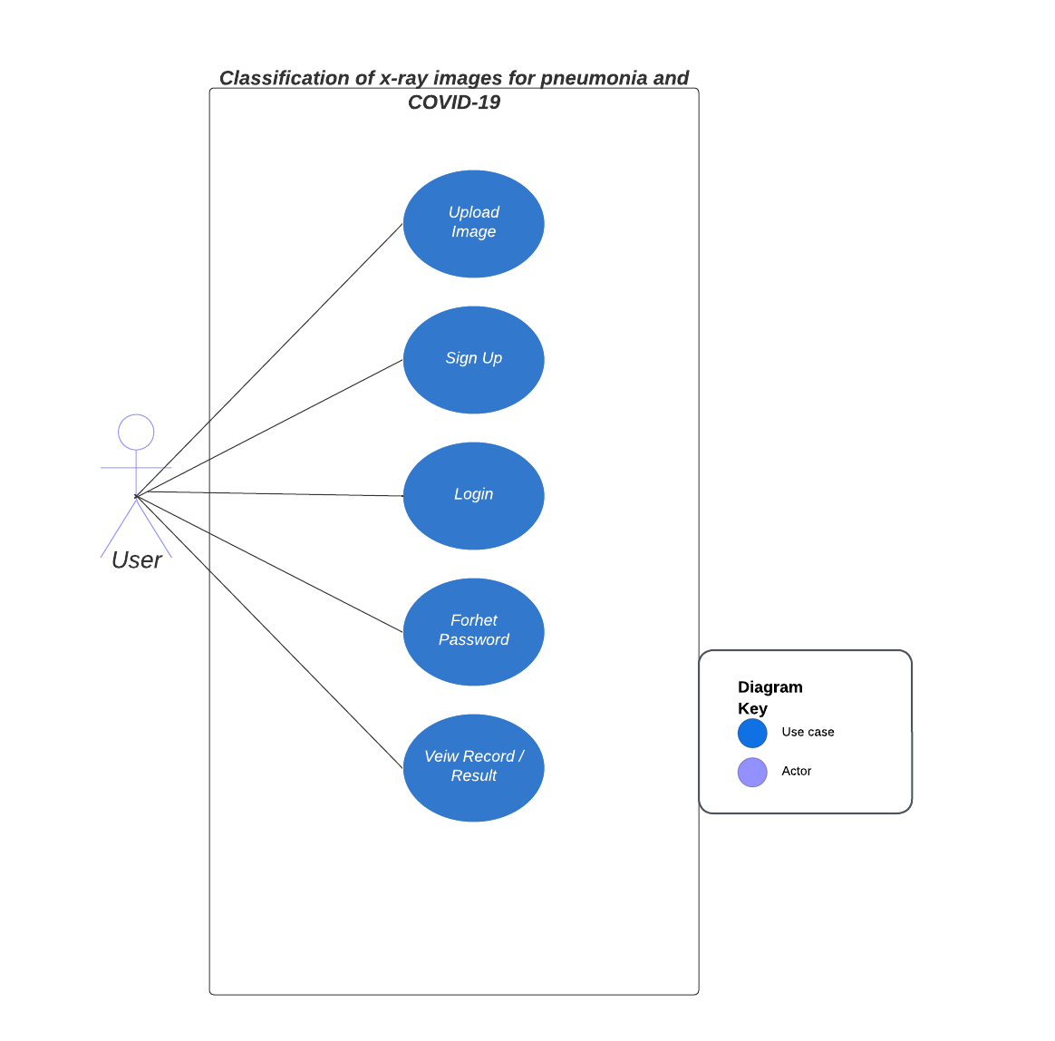

Figure 4. Use Case Diagram

1. **Sequence Diagram**

**Description**

Figure 5 is the Sequence Diagram shows that users can upload images without logging in, but to see the results, they need to sign in first. When users upload an image, they can create an account if they don't have one. After uploading, the system checks if they're logged in. If not, it asks them to sign in or create an account. Once they sign in, the system gets the image results from the database and shows them to the users. This helps keep data safe and ensures everything works smoothly.

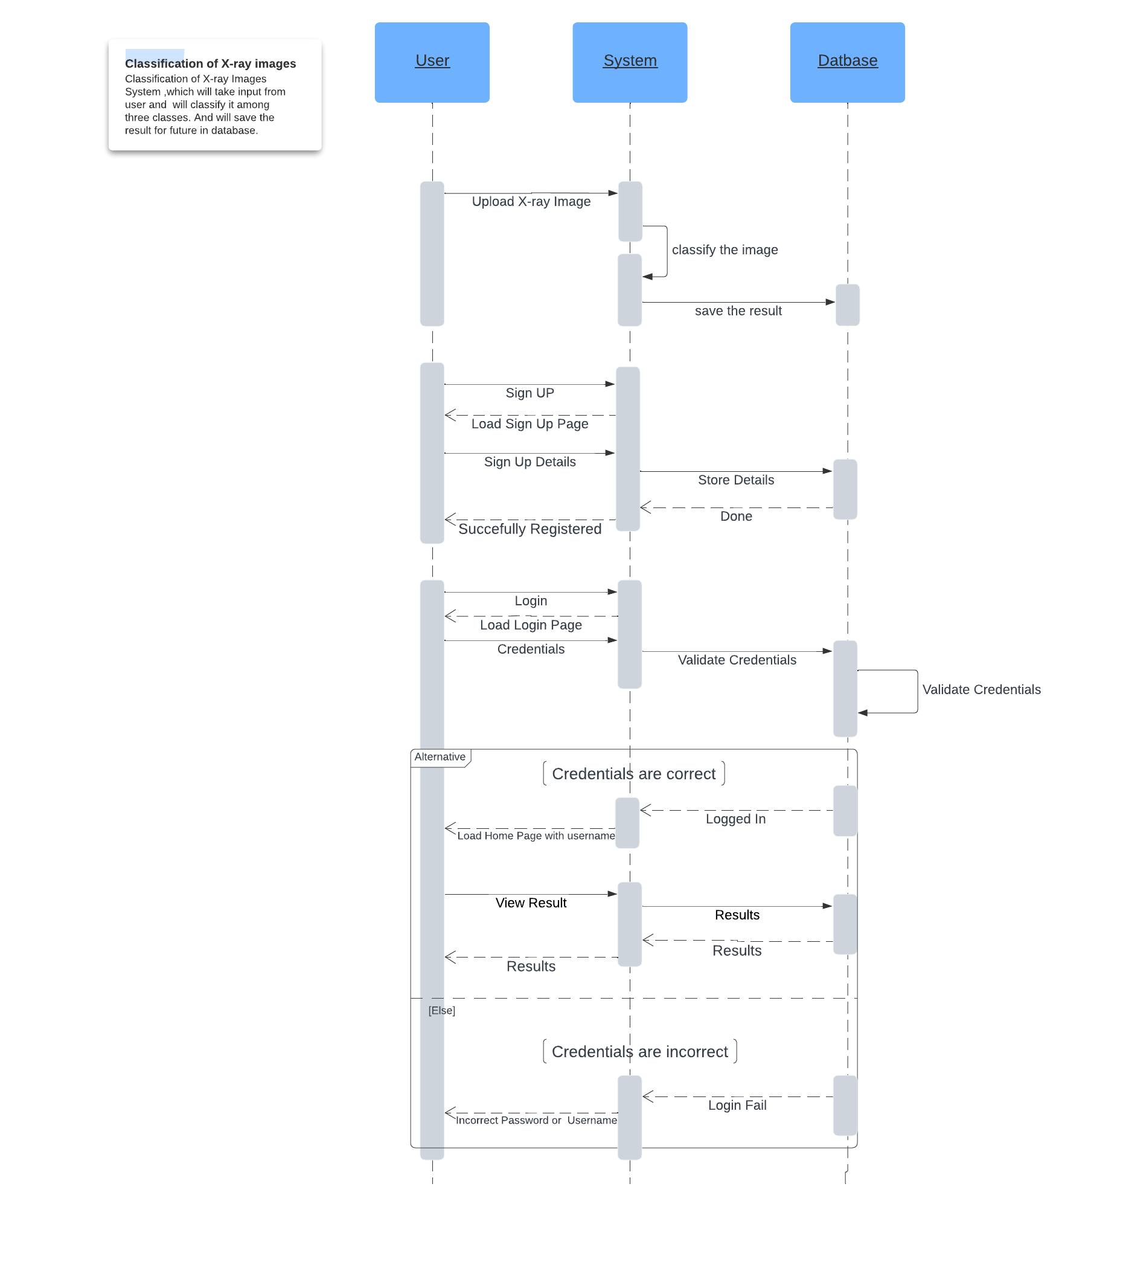

Figure 5. Sequence Diagram

1. **Interface Design**

**Description**

Figure 6 is the above attached diagram is of Home page of the Web application for the system “X-ray Image Classification for Pneumonia & COVID-19”. The navbar offers link to further two pages; About section contains information of the system designers, and Records takes you to the record page . The home page contains two buttons for Upload image and Show Results; actions. Upload image button asks to upload the chest X-ray image for classification. Show Results button redirects to the results/record page to show the diagnosis.

## **Index page**



Figure 6. Home Page of Web Application

**Description**

Figure 7 is the above attached diagram is of Register page of the Web application for the system “X-ray Image Classification for Pneumonia & COVID-19”. This page is designed to register the user for using system properly. If the user is already registered he/she can login directly with authentic login credentials.

## **Sign Up Page**

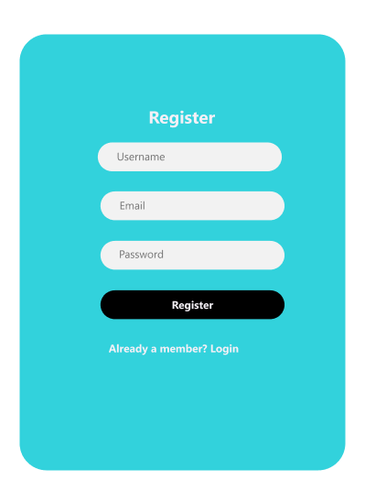

Figure 7. Sign Up Page of Web Application

**Description**

Figure 8 is the above attached diagram is of Login page of the Web application for the system “X-ray Image Classification for Pneumonia & COVID-19”. This page is designed to login the system with authentic login credentials. If the user has not registered yet, he/she needs to get registered first, in order to use the system.

## **Login Page**

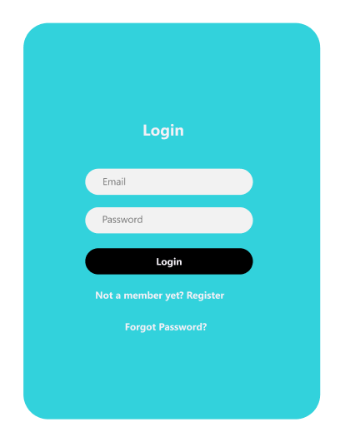

Figure 8. Login Page of Web Application

**Description**

Figure 9 is the above attached diagram is of About Us page of the Web application for the system “X-ray Image Classification for Pneumonia & COVID-19”. This page is designed to give introduction of the system designers.

## **About Us Page**

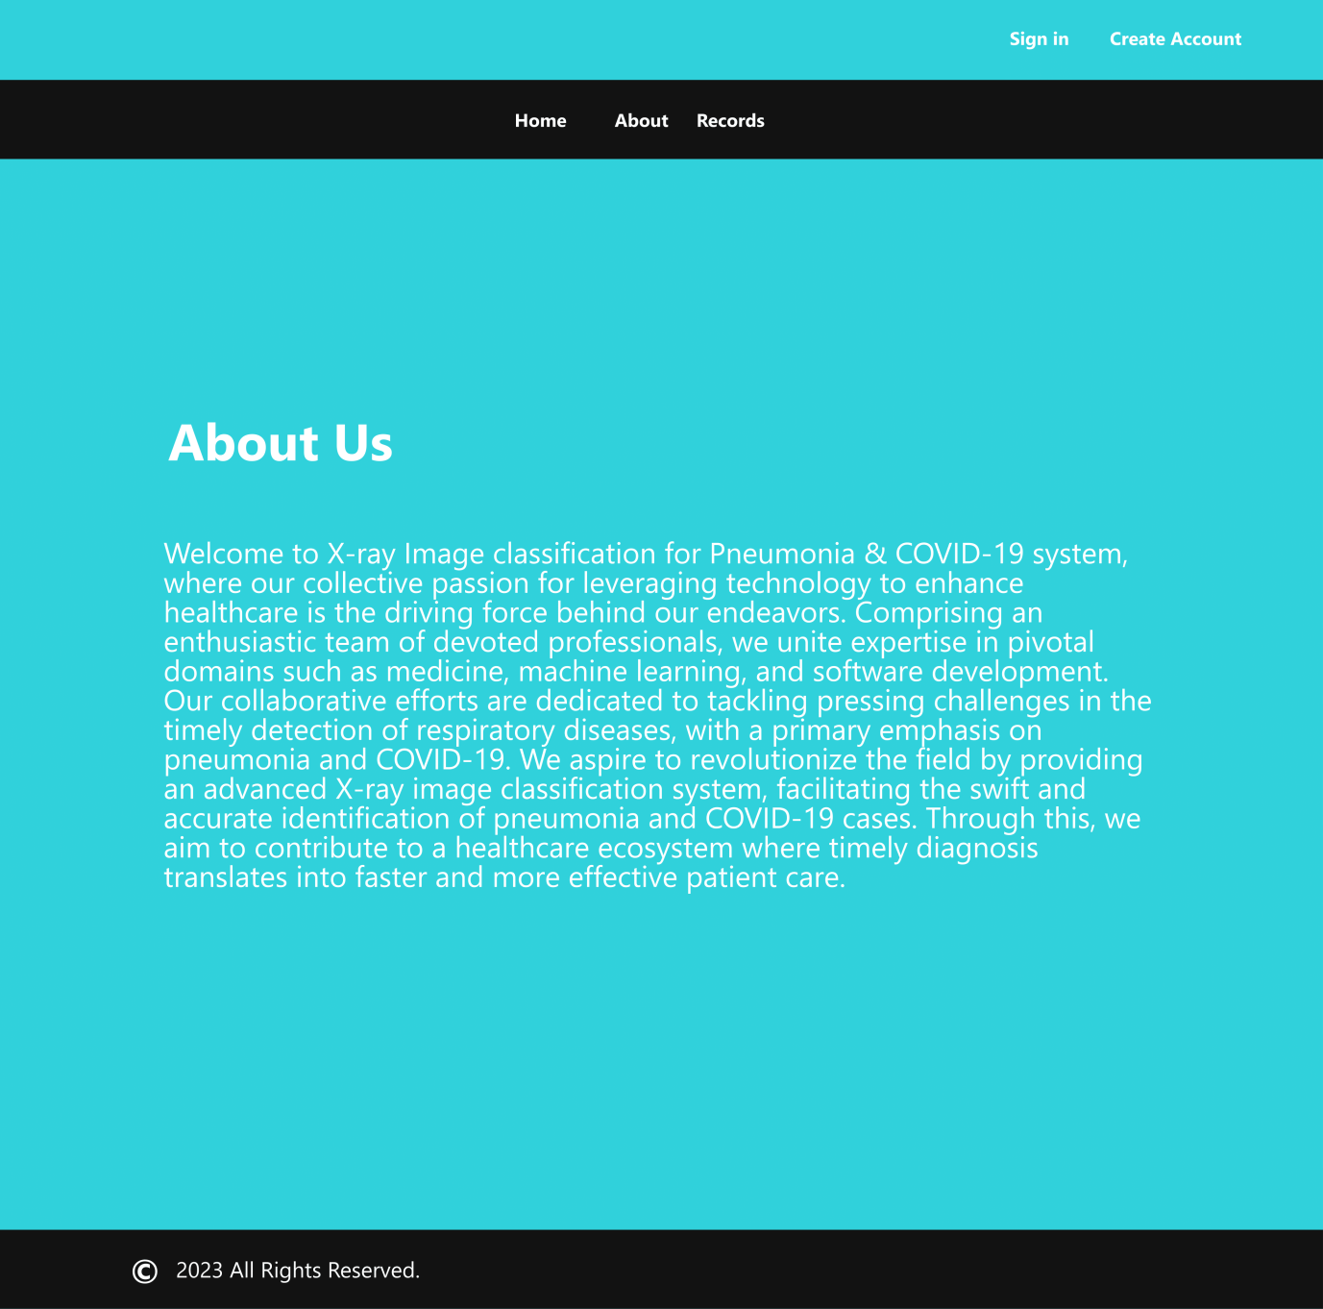

Figure 9. About Us Page of Web Application

**Description**

Figure 10 is the Records page of the Web application for the system “X-ray Image Classification for Pneumonia & COVID-19”. This page is designed to give user the information about the diagnosis along with patient name and the date. In order to provide user a better experience of the system the “Download Records” button is available. So that user can download the records and can further consult with the physician.

## **Records Page**

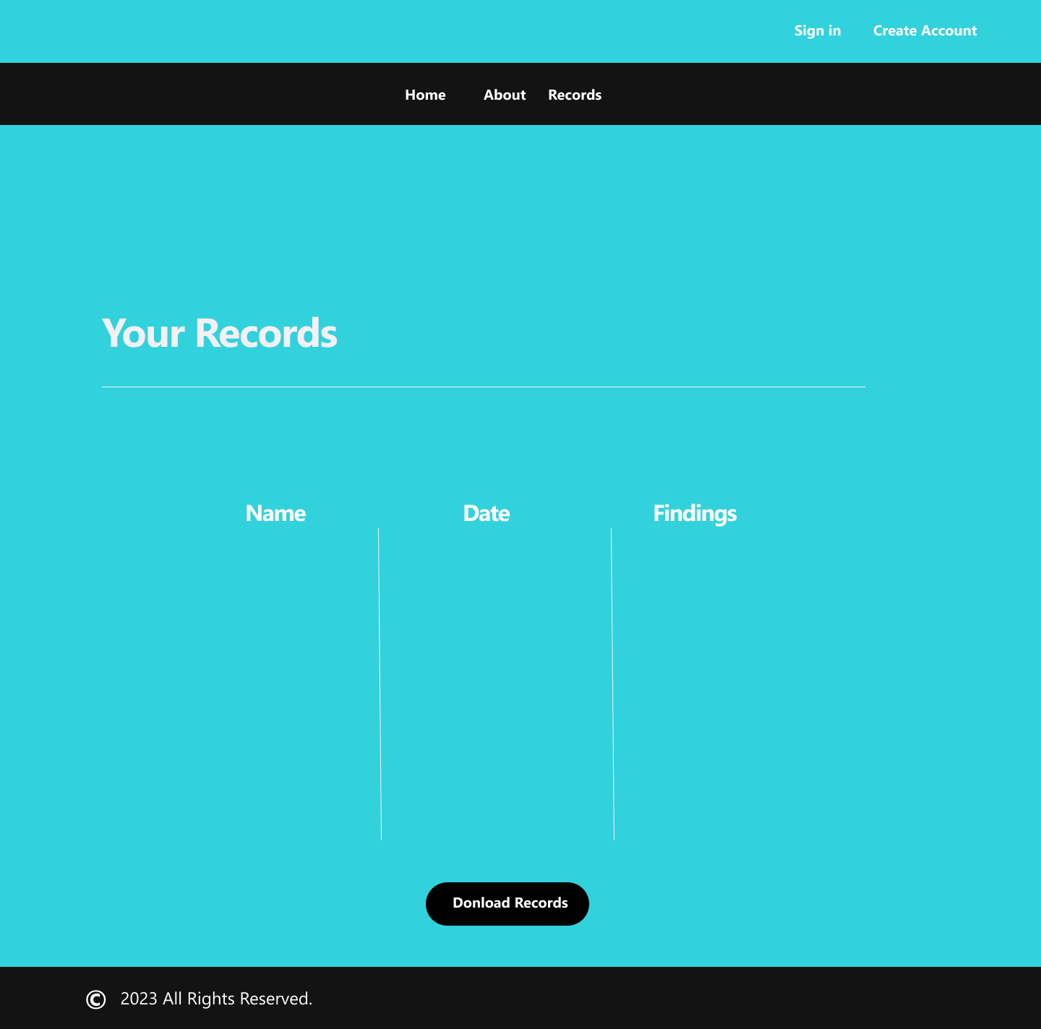

Figure 10. View Records Page of Web Application

**Description**

The above Figure 11 provides mobile view of Home page of the Web application for the system “X-ray Image Classification for Pneumonia & COVID-19”.

## **Mobile Interface**

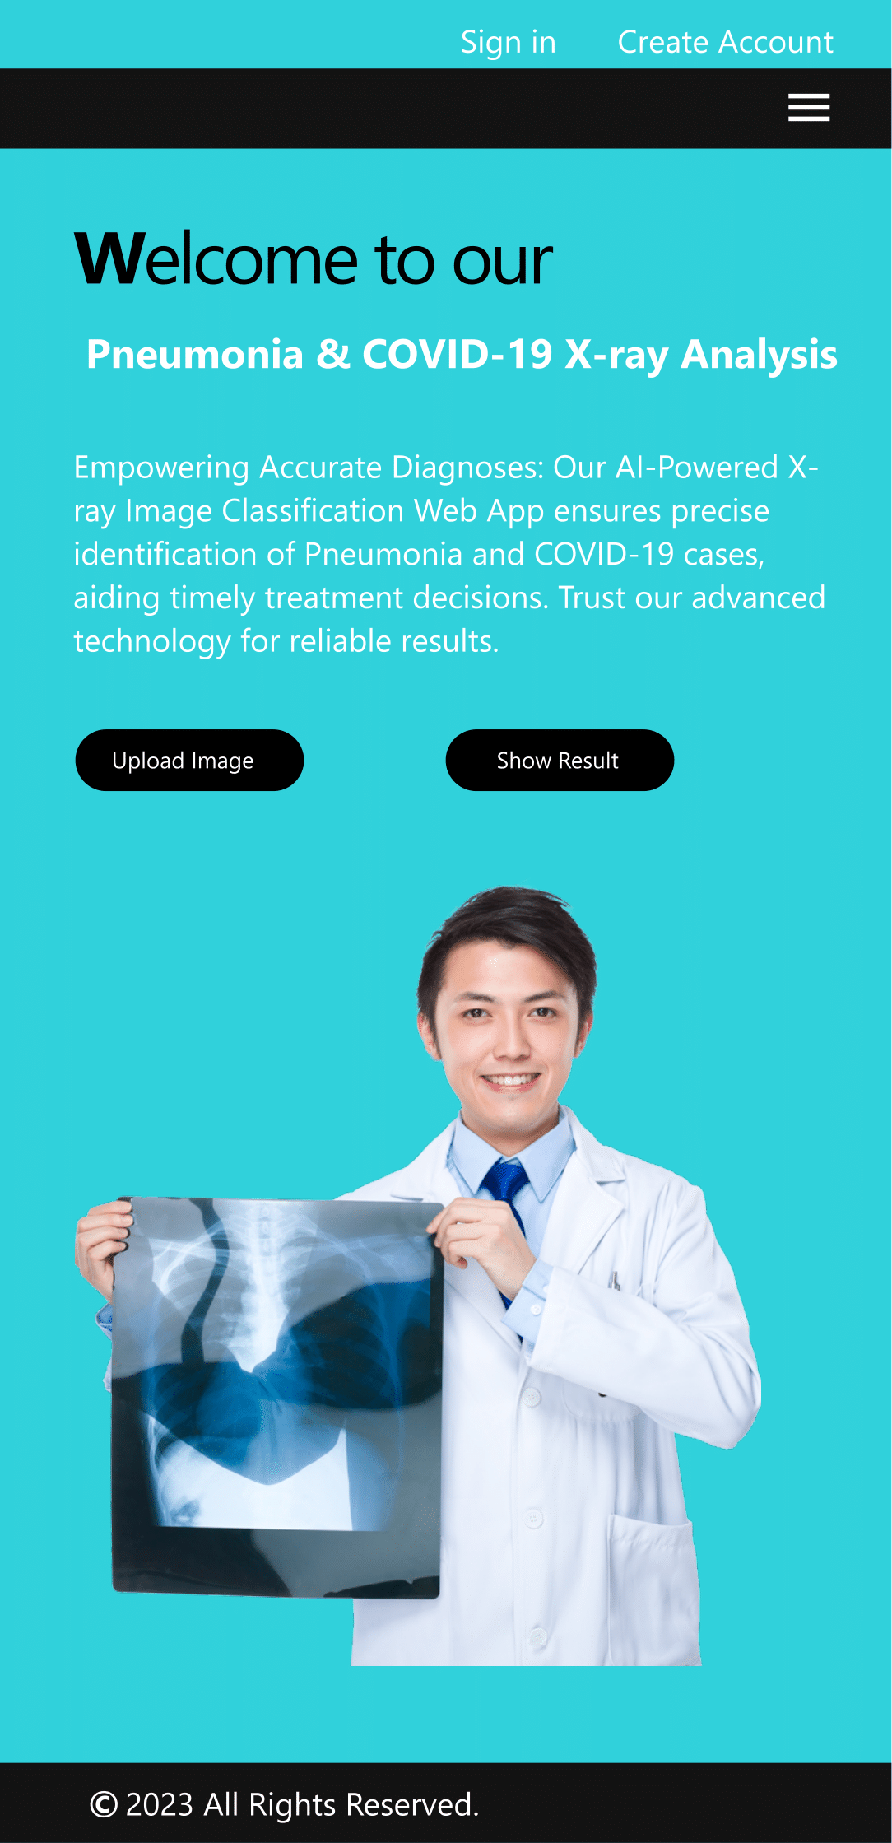

Figure 11. Mobile View of Web Application